A PROJECT REPORT

ON

### “CareZone Website”

SUBMITTED

By

SIMRAN TAMBOLI

(PRN:04518003420)

Towards The Partial Fulfillment of the

## Master of Computer Application

TILAK MAHARASHTRA VIDYAPEETH

[PUNE]

TILAK MAHARASHTRA VIDYAPEETH, PUNE

Faculty of Distance Education

[2020-2021]

Tilak Maharashtra Vidyapeeth, Pune

MCA

**CERTIFICATE**

This is to certify that the project

“*CAREZONE WEBSITE”*

Has been satisfactorily completed by

SIMRAN TAMBOLI

Towards The Partial Fulfillment of the Master’s of Computer Application,

For the Academic Year 2021 at Tilak Maharashtra Vidyapeeth Center,

Pune,

Tilak Maharashtra Vidyapeeth, Pune (Faculty of Distance Education),

And it is approved.

Project Guide Examiner Head of Department

Tilak Maharashtra Viyapeeth –Pune

Tilak Maharashtra Vidyapeeth, Pune

MCA

**ACKNOWLEDGEMENT**

I am very Grateful to present the Project on

**“CAREZONE WEBSITE”**

I would like to take this opportunity to thank all those who helped me to complete this project with their Guidance, Co-operation and support.

I would like to thank my guide teacher Mrs.Shruti Gosavi and Head of Department Mrs.Asmita Namjoshi for their valuable guidance.

I also owe special thanks to our friends for providing the friendly and cordial environment to achieve the goal, without their contribution this project would not have been successful.

Most importantly I thank our parents who guided and supported us simultaneously in project and achieving goal.

SIMRAN TAMBOLI

(MCA)

**PROJECT SYNOPSIS**

**CAREZONE WEBSITE:**

* Objective/Aim of the System:

Cancer CareZone Website is to spread awareness about Cancer and Cancer causing Health issues in our environment .through CareZone Website we can motivate people by giving them examples of Cancer Survivor’s message and help them motivate and come out of their situation .

It will not only help people but aware them about the health issues causing by Cancer.

* Technical Details:

CareZone Website is to spread awareness about Cancer and Cancer causing Health issues in our environment.

This website is made in Windows 10 with Processor 2.2Ghz, RAM 8GB and ROM 500GB.

It has a user friendly UI(User Interface)that people can easily operate the website .

It has the frontend coding with High level languages Angular11,HTML,CSS,Typescript,Angular Material.

It has Backend In Memory and Packages like Firebase API,Angular11 and Json.

**INDEX**

|  |  |  |
| --- | --- | --- |
| **Sr.No** | **Content** | **Page No** |
| **1** | **Introduction**   * 1. **Introduction to project**   2. **Scope of the System** | **6-7** |
| **2** | **Functioning of the System**   * **Functioning** | **8-9** |
| **3** | **Proposed System**   * **Objective of the System** | **10-11** |
| **4** | **Requirement Analysis** | **11-12** |
| **5** | **Diagram/Analysis and Design** | **13-21** |
| **6** | **Screenshots** | **22-53** |
| **7** | **Future Scope** | **54** |
| **8** | **Limitation** | **55** |
| **9** | **Conclusion** | **56** |
| **10** | **Bibilography** | **57** |

**INTRODUCTION OF THE WEBSITE**

CAREZONE WEBSITE

In This Website any person can search any related information about Cancer on the CareZone Website.

People who are not aware of the Cancer Disease and use to ignore the severity of the disease which may be life threatening.

Cancer CareZone Website helps to spread awareness about the Cancer and Cancer causing health issues in our environment.

It will help people by providing them useful information about Cancer by showing them the survivor’s message videos ,Latest news ,Nearby cancer specialist hospitals through Maps, Symptoms related cancer and also book appointment with Doctors through ChatBot in the website.

**SCOPE OF THE WEBSITE**

* Existing System:

People were not aware about the Cancer disease andthey use to ignore the severity of disease which may be life threatening .

There were no Source from were they could get the information about the

Disease due to lack of Technology.

* Need of the System:

Cancer CareZone Website is to spread awareness about Cancer and

Cancer causing Health issues in our environment. Thorugh CarZone

Website we can motivate people by giving them examples of cancer

Survivor’s message videos and help them to come out of their situation

It will not only help people but also Aware them about the health issues

Causing by Cancer.

**FUNCTIONING**

**FUNCTIONING OF THE WEBSITE**

It will be quiet easy Website to work on ,User can simply operate the website available on Google.

As The Website is CareZone Website it is a informative website for the people Diagnos with Cancer .They can easily get the information about Cancer and Cancer related Health issues on this website.

As this Website has Chatbot user can also book appointment through Chatbot with the Cancer Specialist doctors.

They can also find Nearby Cancer Hospitals through Map in the Website.

CareZone Website is User Friendly and Informative Website.

**PROPOSED SYSTEMOBJECTIVE OF THE WEBSITE**

As Compared to Manual Work ,this Website is much informative and Save Lots of time of the user by gathering all information related Cancer in Carezone Website.

User does not have to search for Cancer related information in different platforms as CareZone Website provide all information in one website related Cancer and Cancer Health issues.

This website is easy to use and User Friendly, this Website has instant Updating of information.

It Keeps the Website Scalable.

**REQUIREMENT AND ANALYSIS**

**REQUIREMENT ANALYSIS**

Hardware Specification:

* For Windows:
* Processor:2.2Ghz
* RAM: 8GB
* ROM:500GB

Software Specification:

* Operating System: Windows 10
* **Frontend:** Angular11 , HTML ,CSS, Typescript ,Angular Material.
* **Backend:** In Memory.
* **Packages:** Firebase API , Angular11, Json.

**Diagrams/Analysis and Design**

**FLOWCHART**

**Book appointment on Chatbot**

**Map for nearby Hospital**

**Treatment**

**Doctor’s Consult**

**Symptoms Related Cancer**

**Survivor video message**

**Information About Cancer**

**Patient Diagnosed Cancer**

**ENTITY RELATIONSHIP DIAGRAM**

**ENTITY RELATIONSHIP DIAGRAM**

**Dashboard information**

**Survivor’s Message**

**About Us**

**Doctor’s Profile**

**MAP**

**Symptoms**

**Latest News**

**CANCER CAREZONE**

**DATAFLOW DIAGRAM**

**ZERO LEVEL DFD**

**CANCER CAREZONE WEBSITE**

**SURVIVOR’S MESSAGE**

**NEARBY LOCATION MAP**

**CANCER’S SYMPTOMS**

**DOCTTORS INFO**

**PATIENT**

**FIRST LEVEL DFD**

**CAREZONE WEBSITE INFORMATION**

**PATIENT**

**CANCER CAREZONE CHATBOT**

**NEARBY LOCATION MAP**

**CANCER’S DOCTOR PROFILE**

**CANCER SYMPTOMS**

**SURVIVOR’S MESSAGE INFORMATION**

**LATEST NEWS INFORMATION**

SECOND LEVEL DFD

**Checking Cancer Related Details**

**Cancer Related Video Message**

**PATIENT**

**CareZone About Us**

**Cancer related News**

**Cancer CareZone ChatBot**

**Cancer Related hospital Map**

**Doctor’s Details**

**Cancer related Symptoms**

**SCREENSHOTS**

**DASHBOARD SCREENSHOT:**

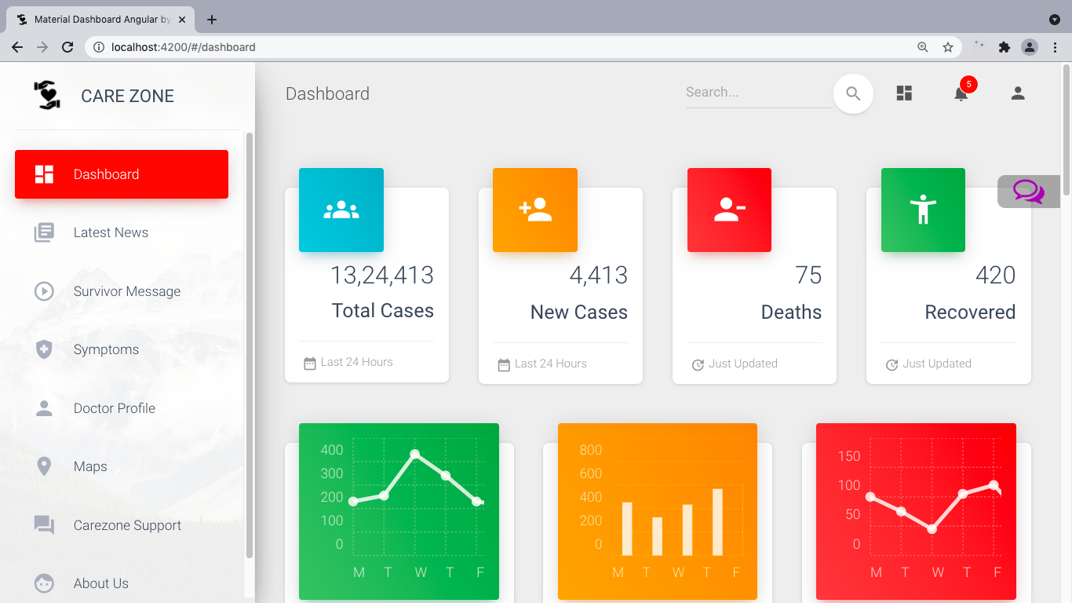

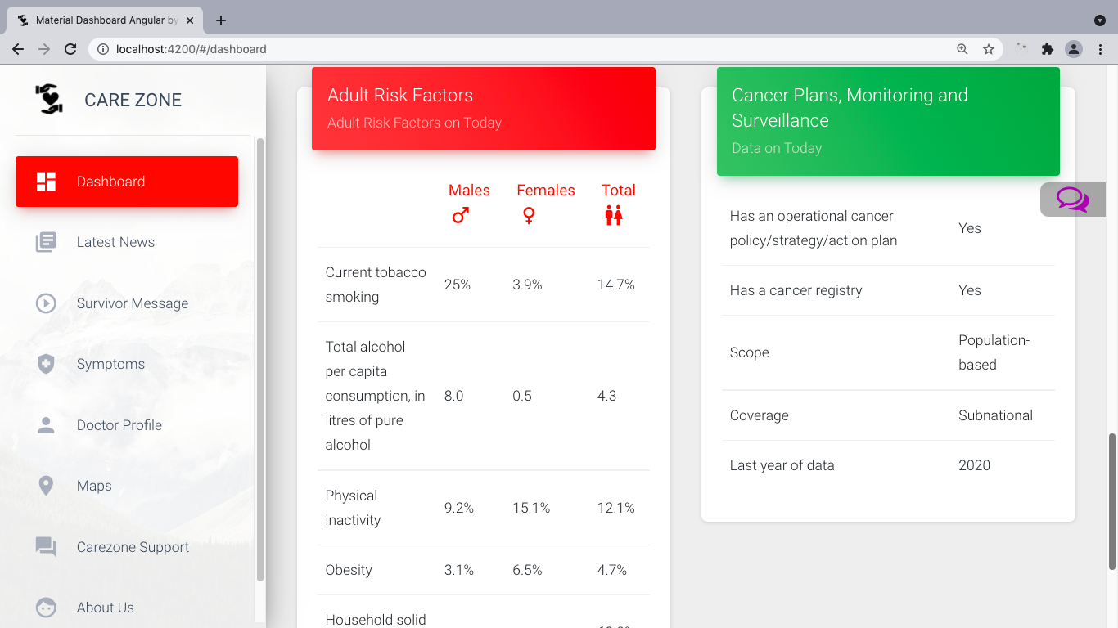

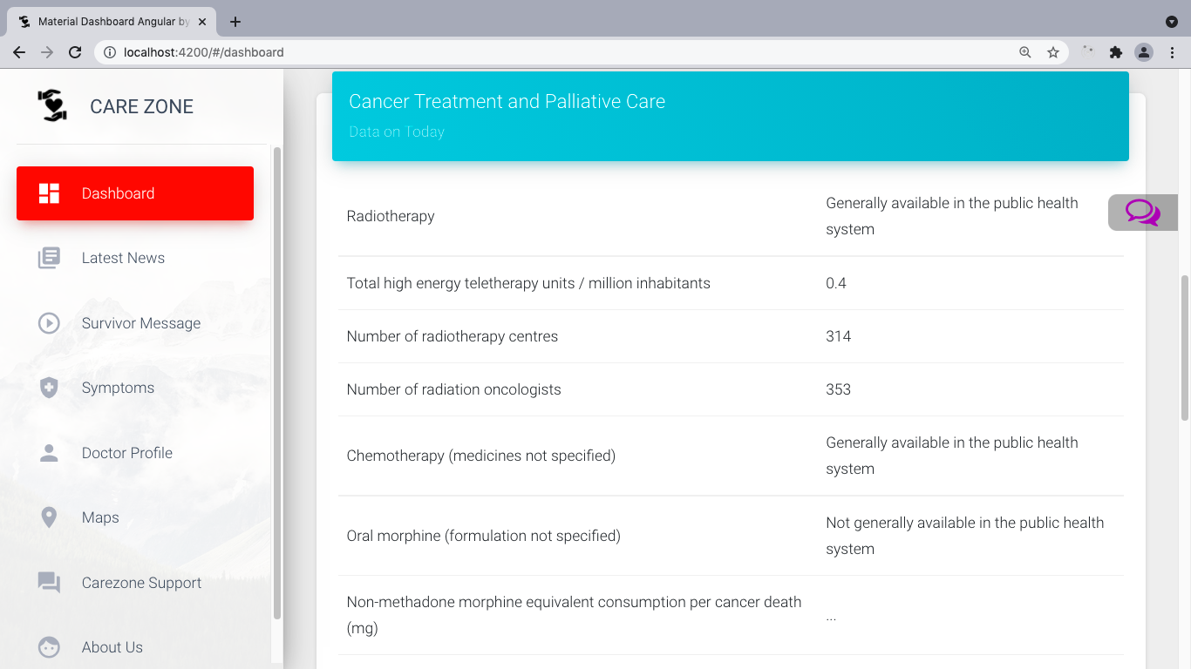

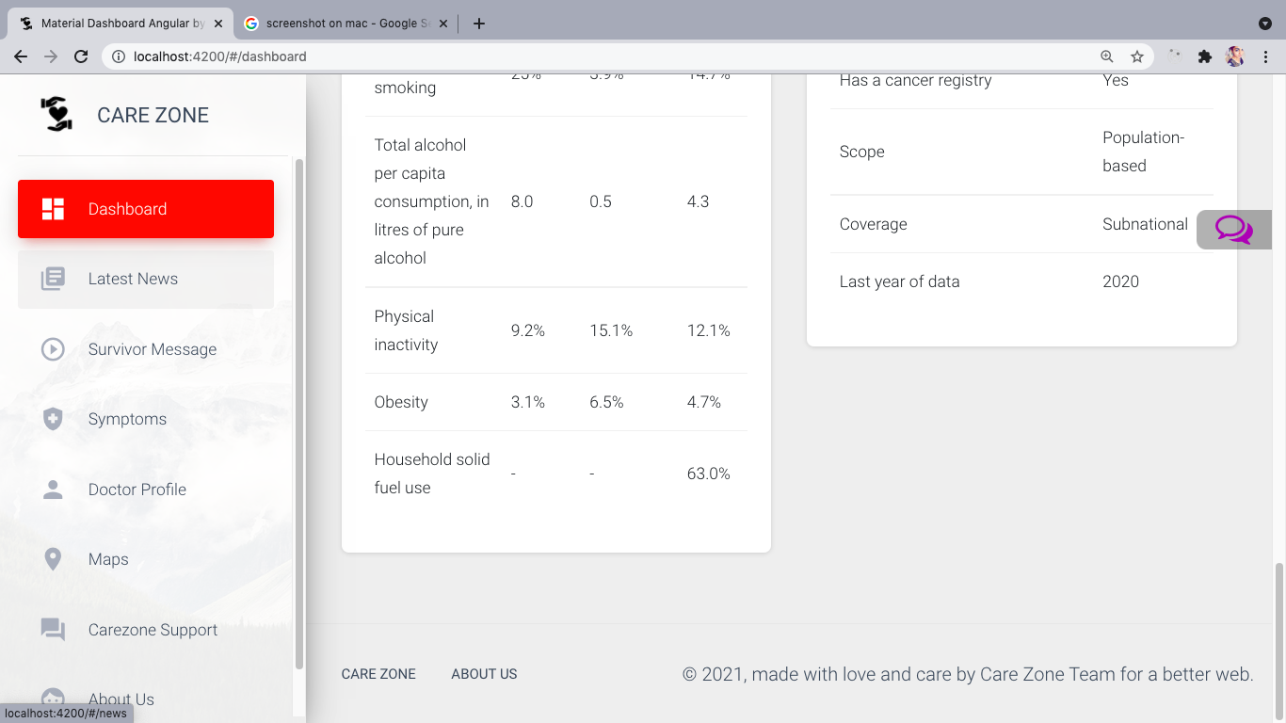

**LATEST NEWS:**

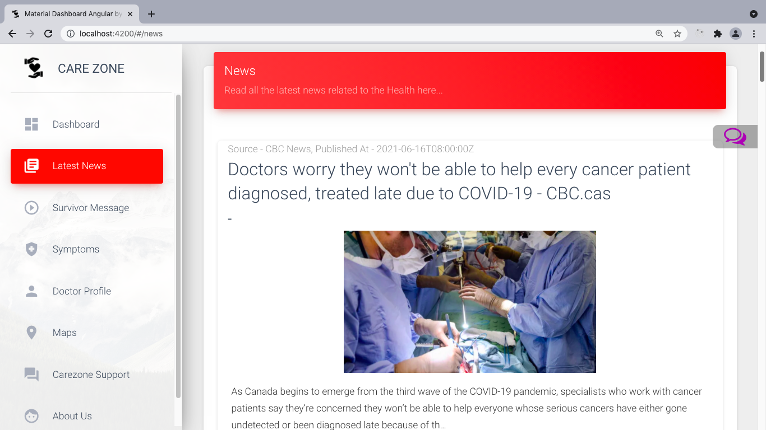

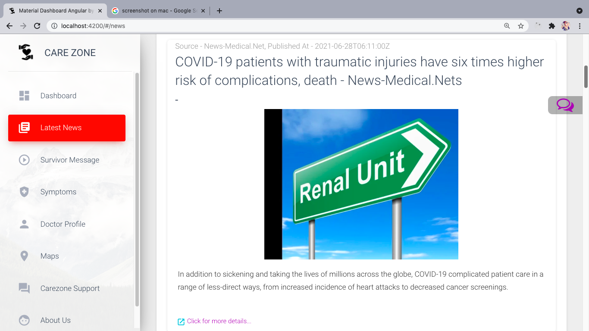

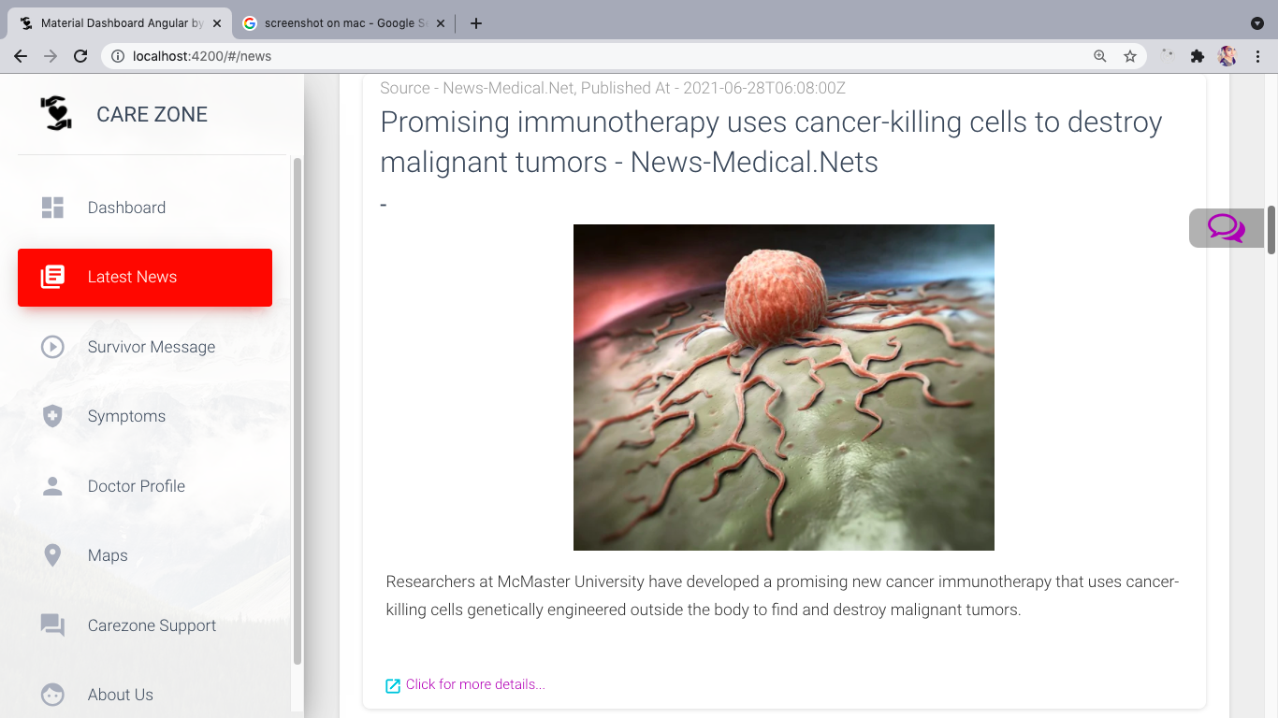

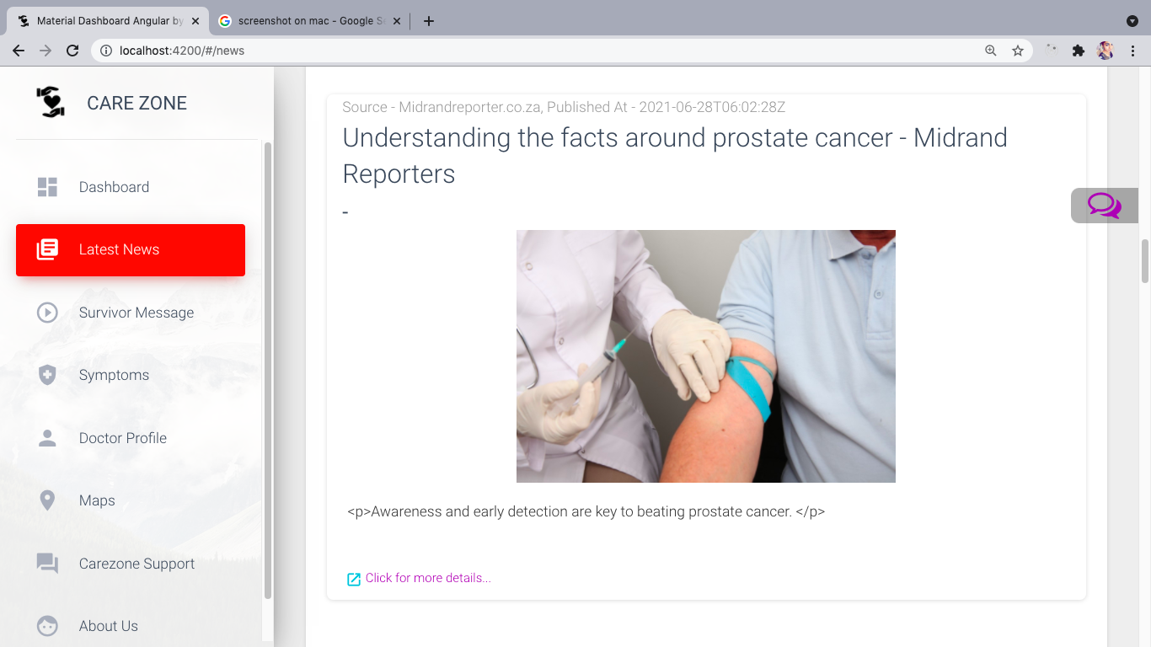

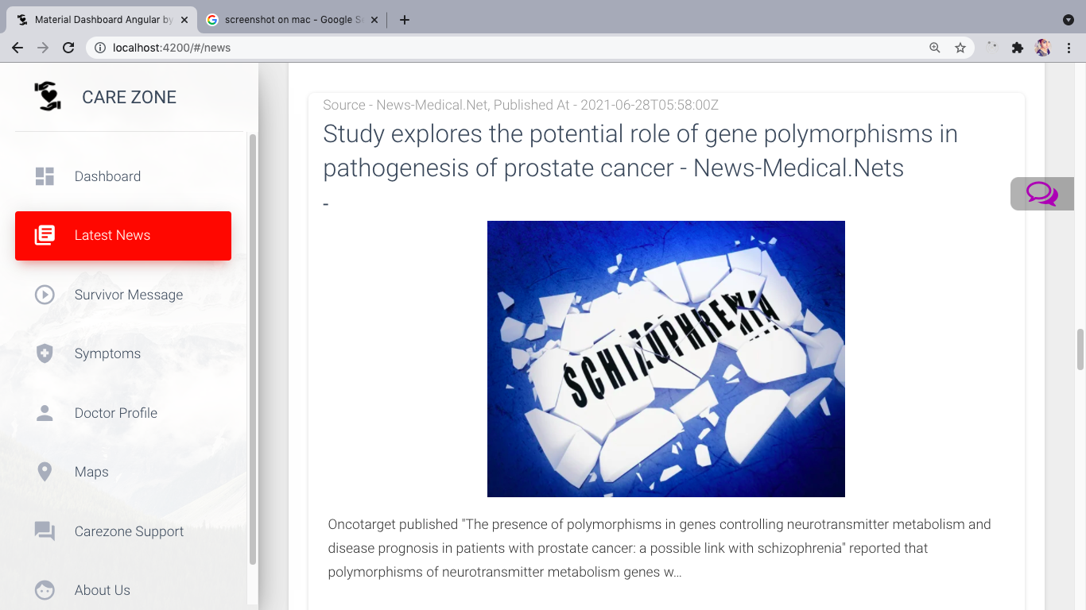

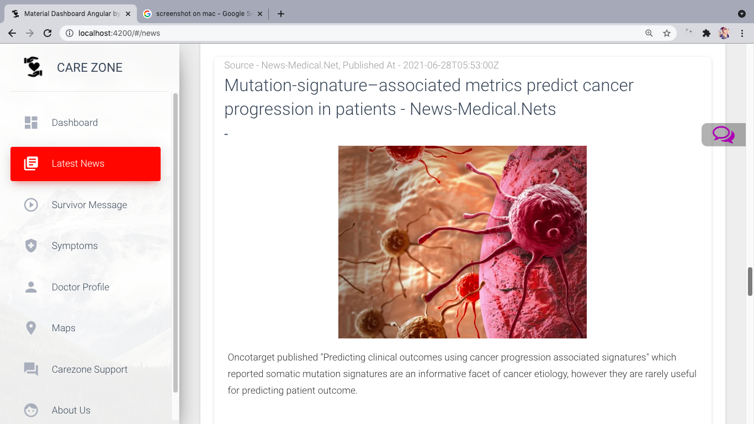

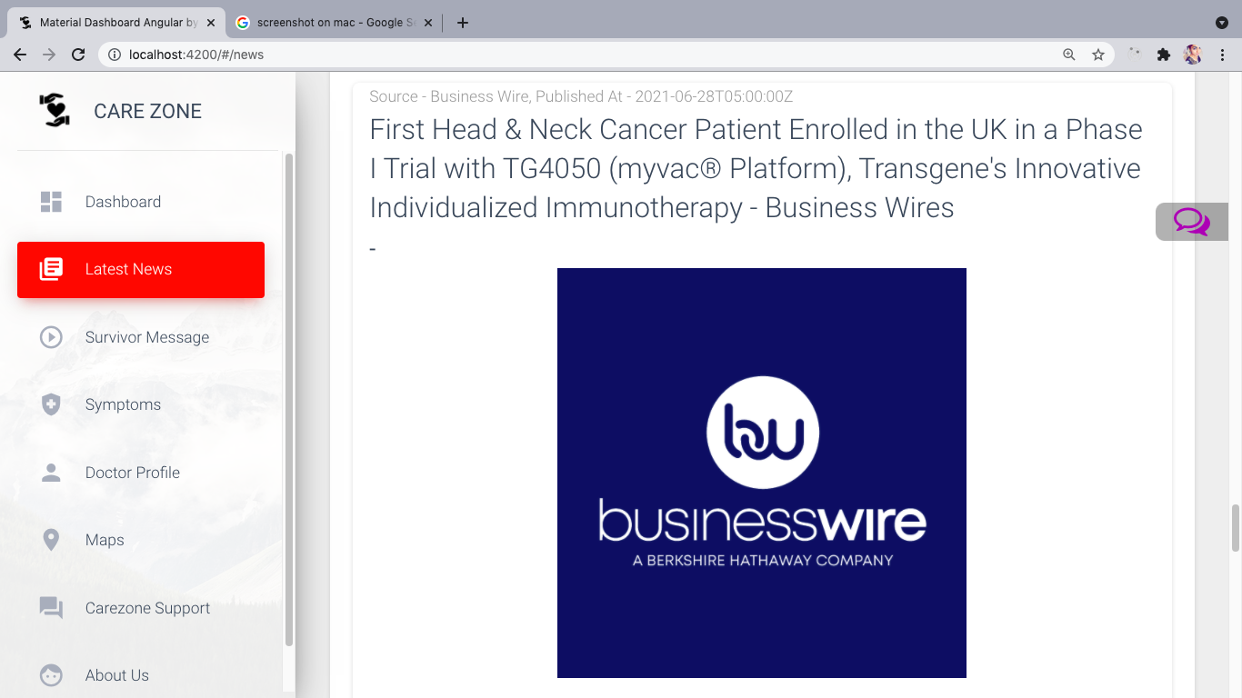

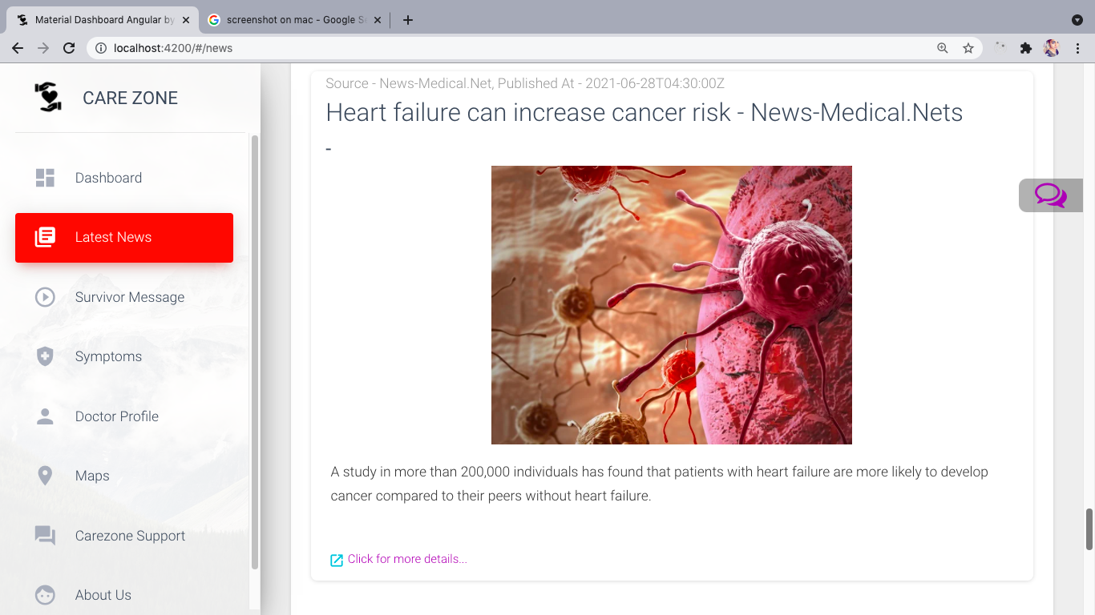

**SURVIVOR’S MESSAGE:**

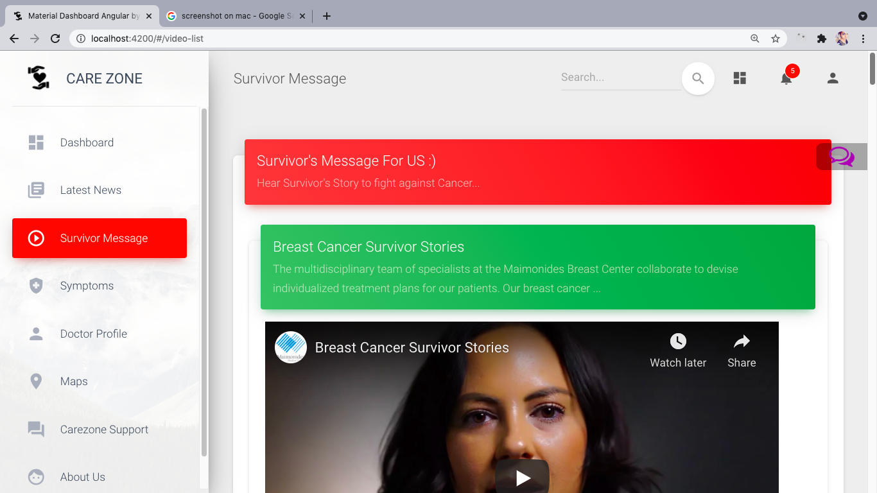

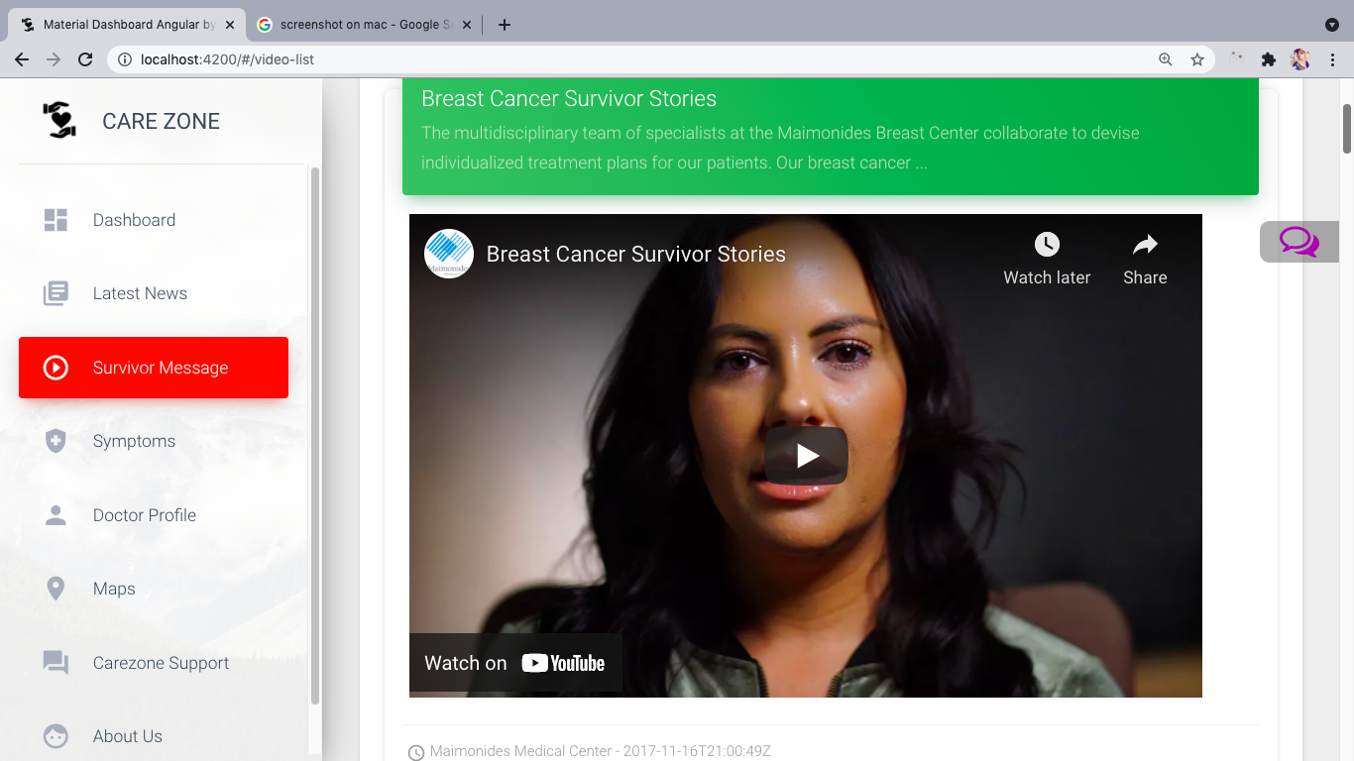

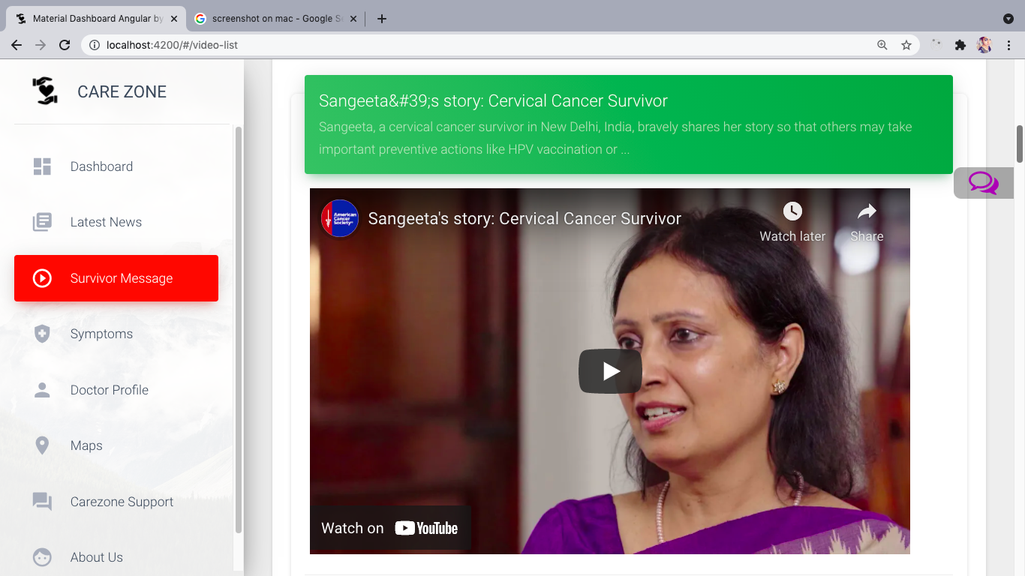

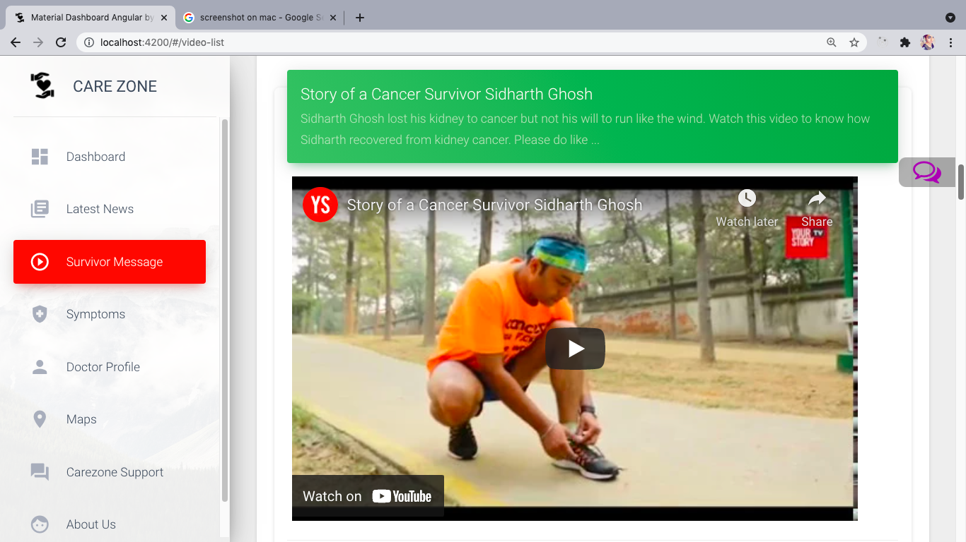

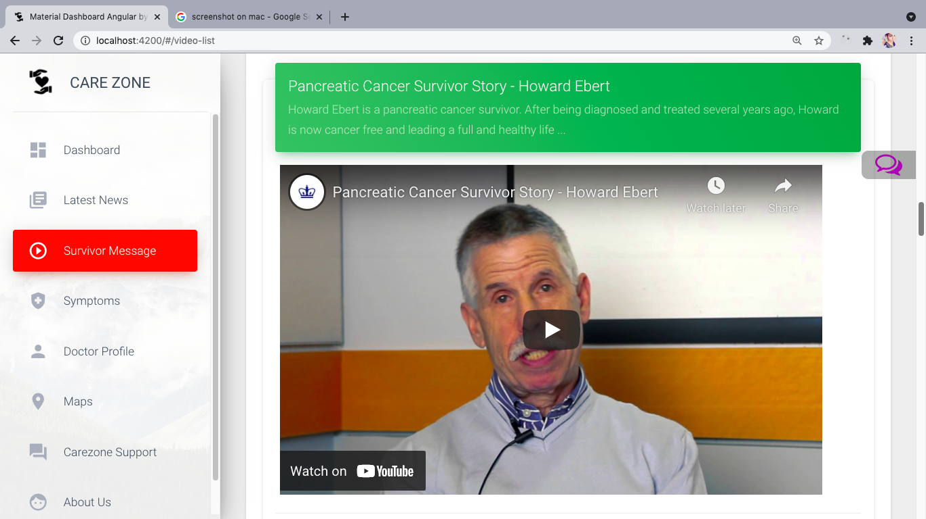

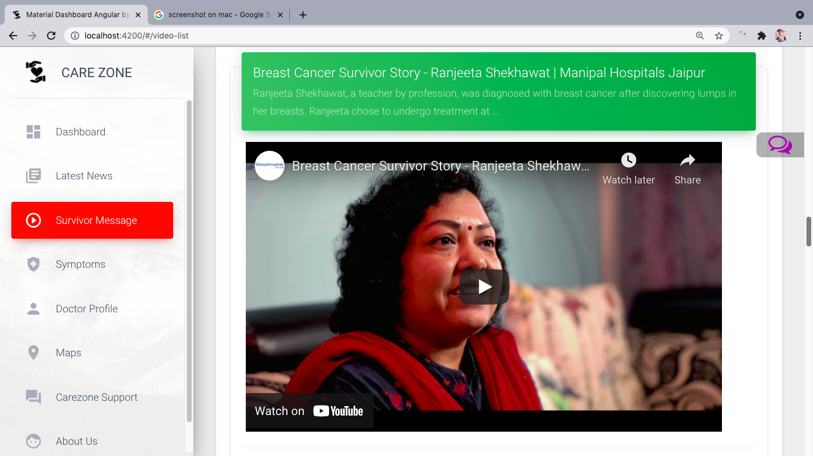

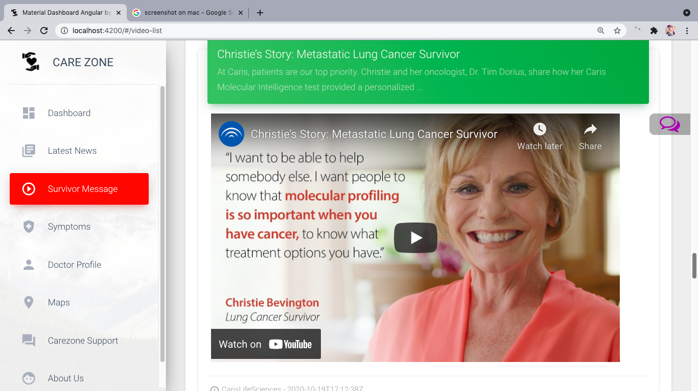

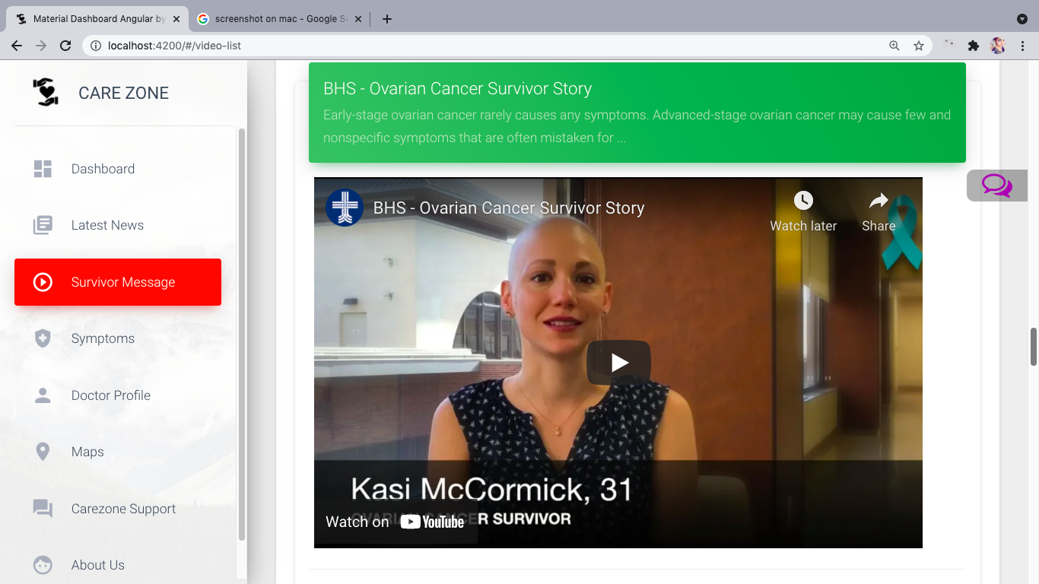

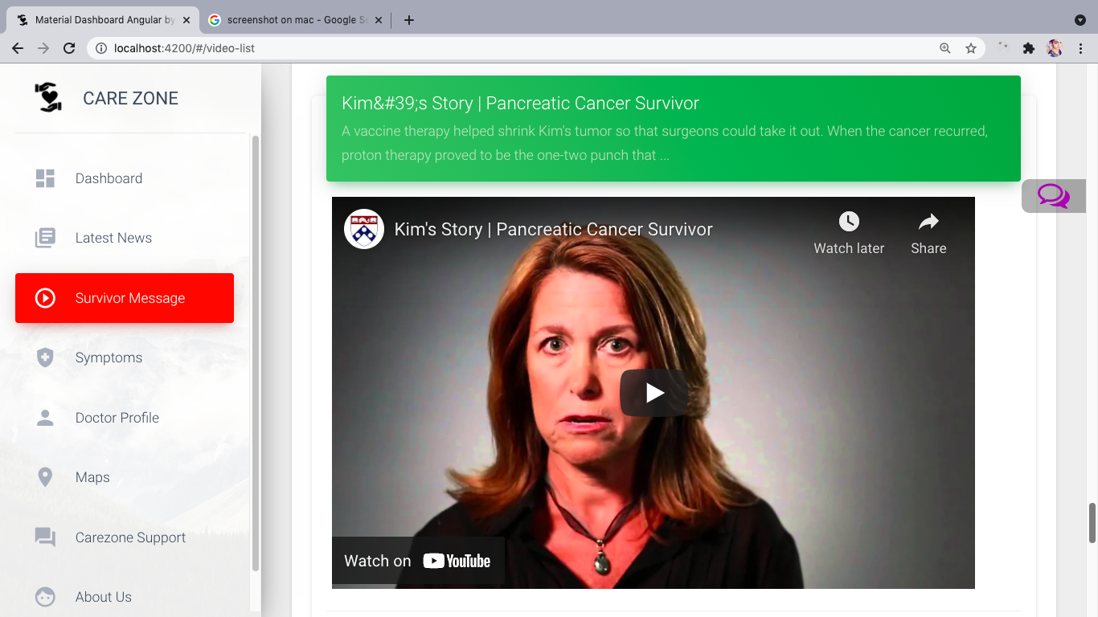

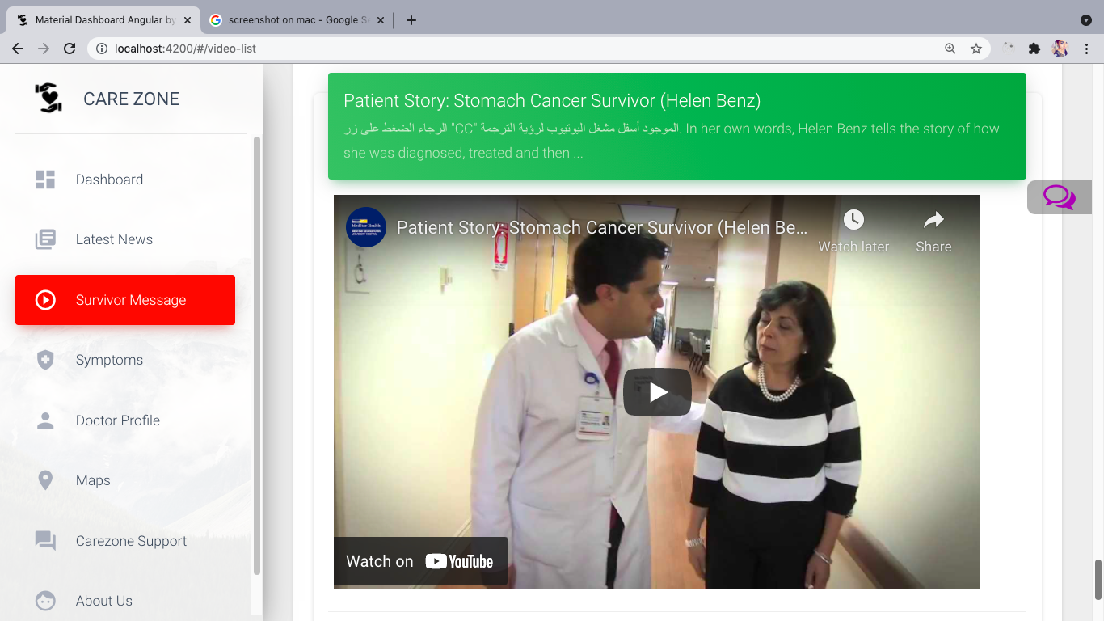

**SYMPTOMS:**

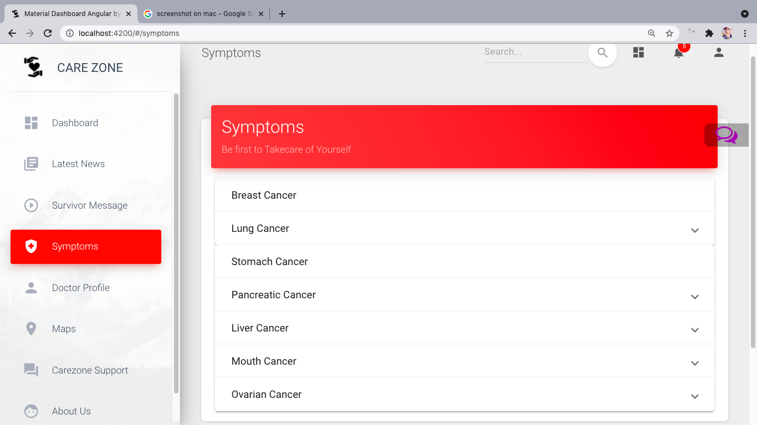

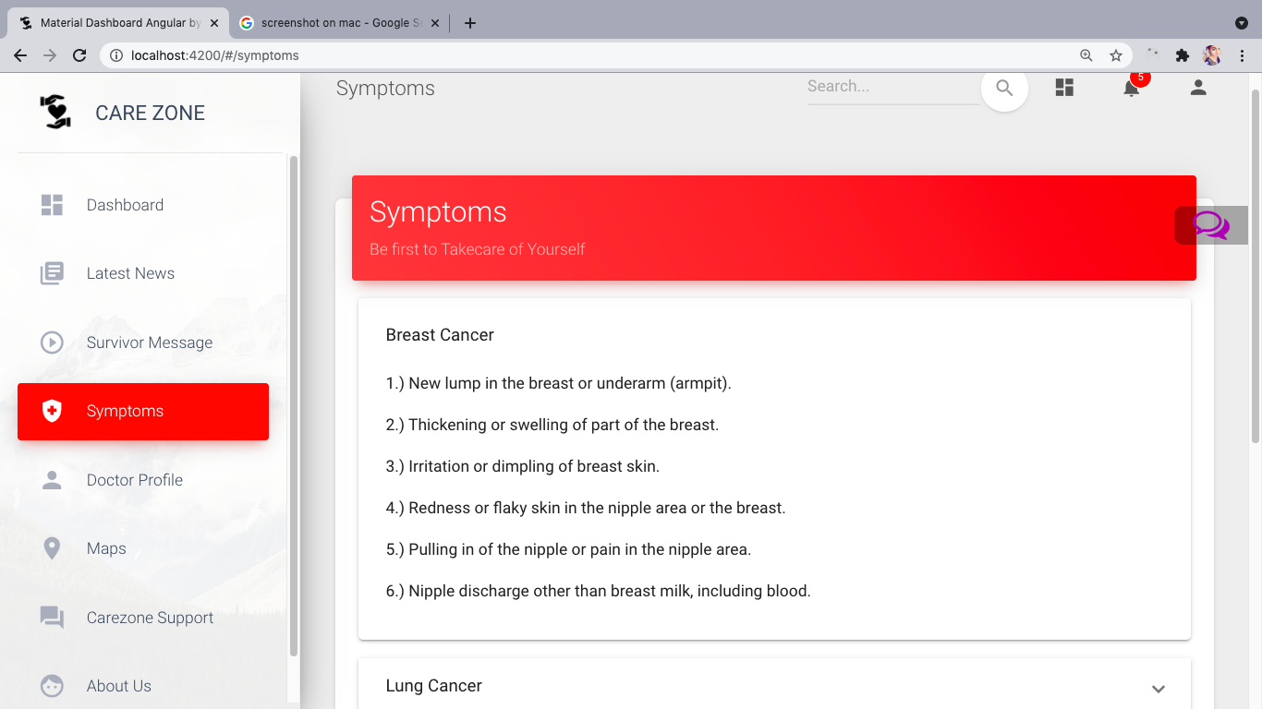

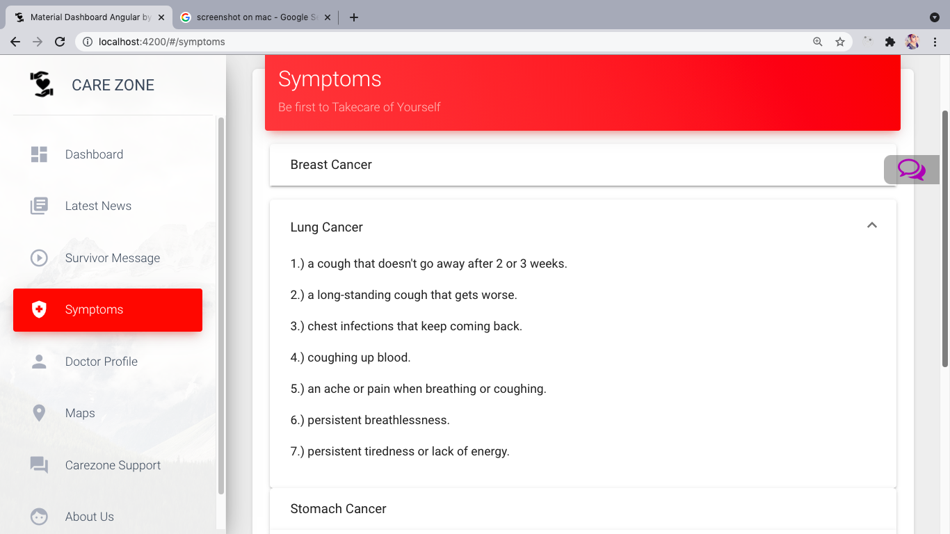

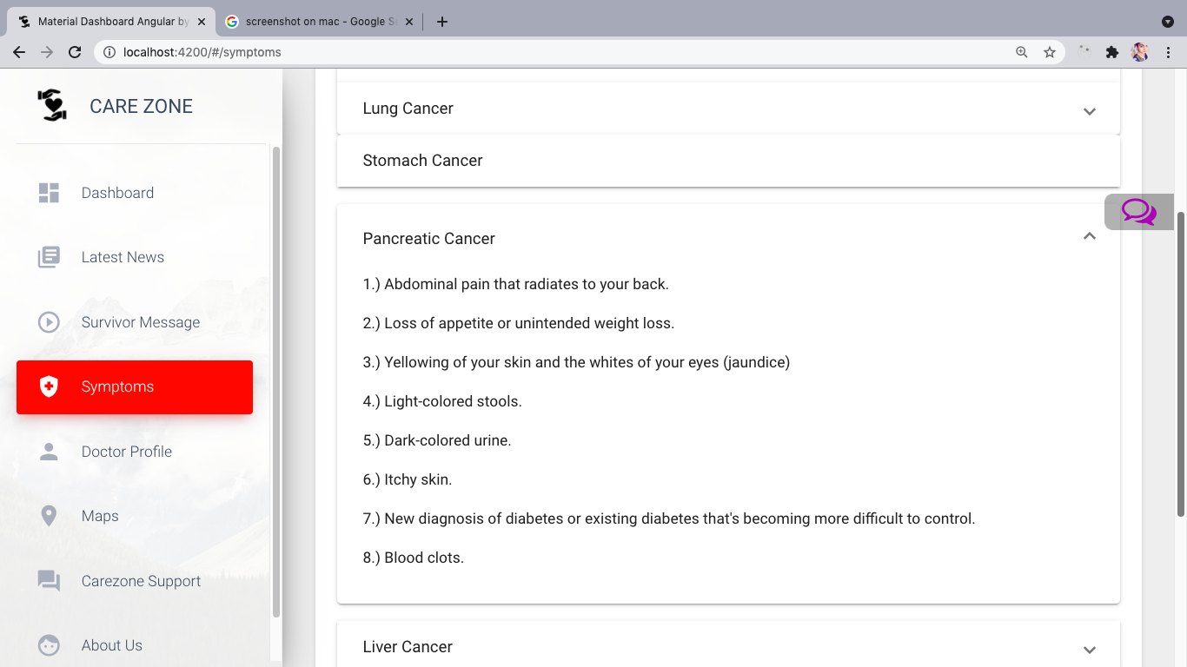

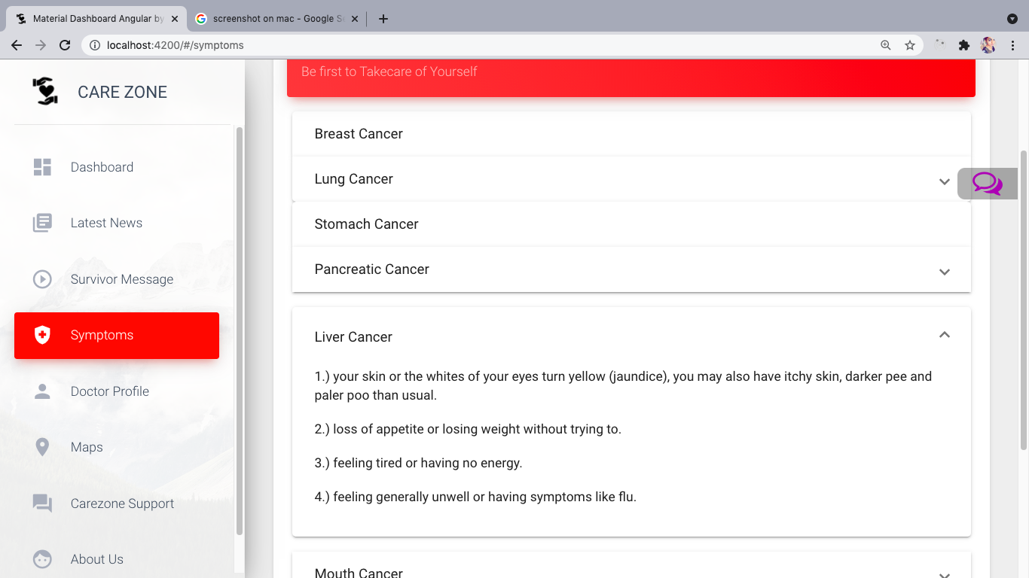

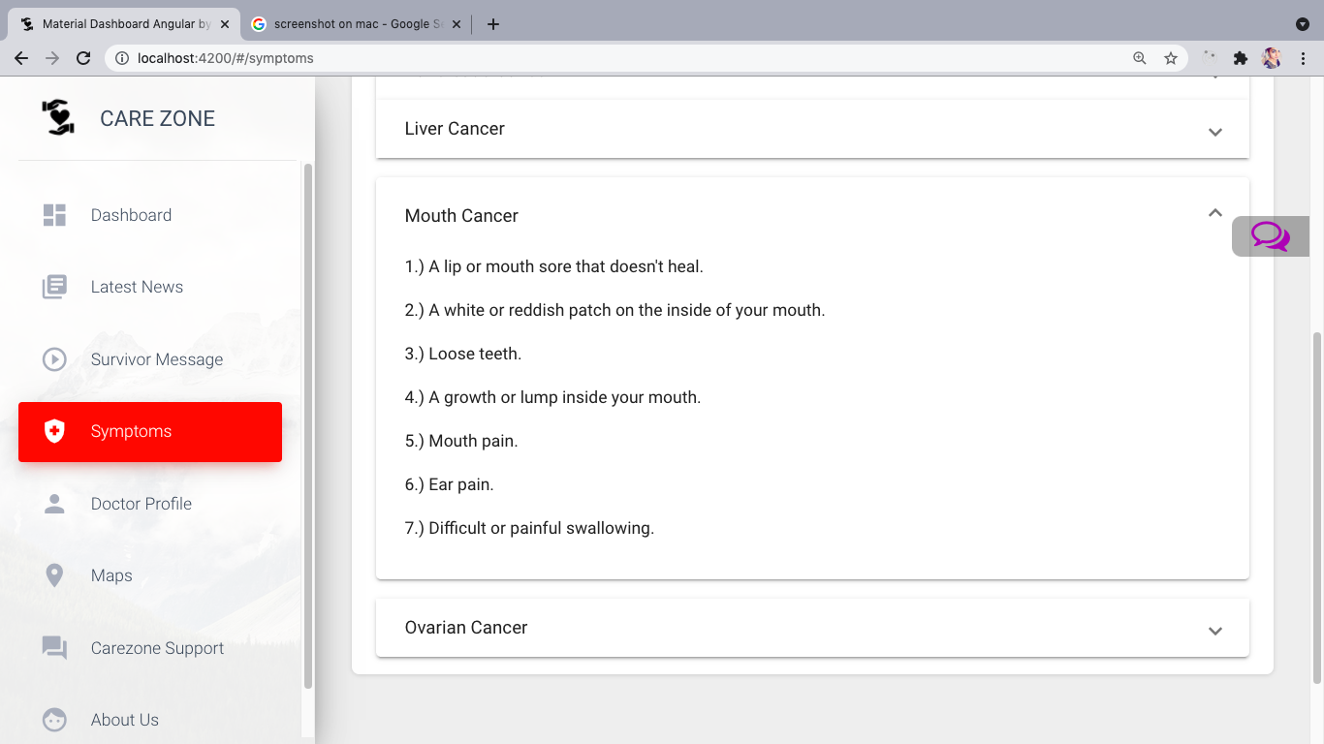

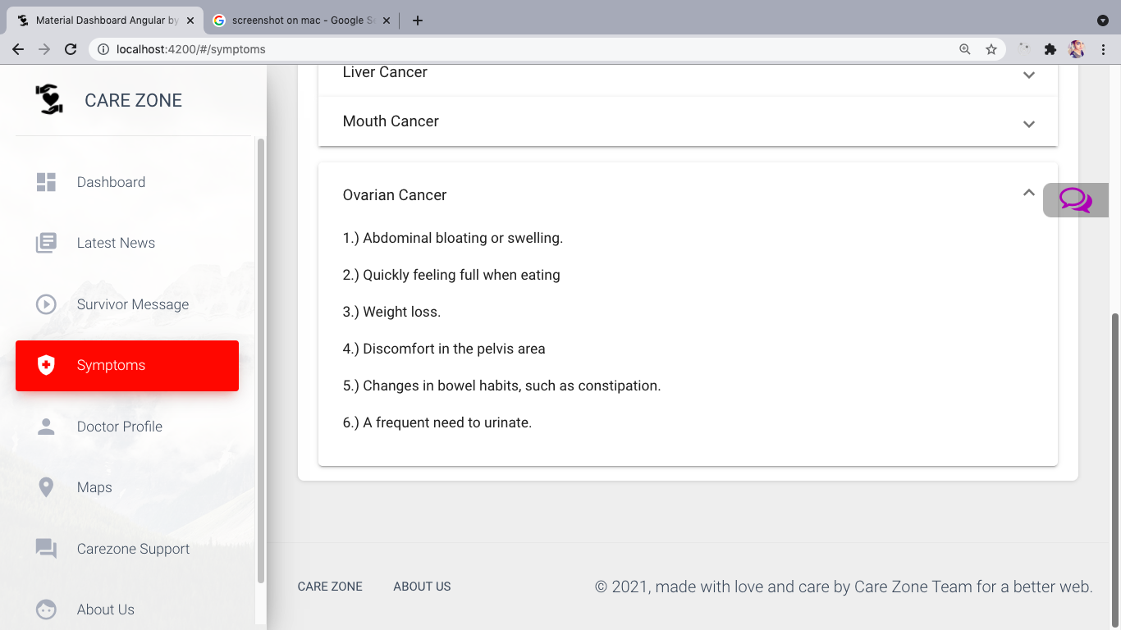

**MAPS:**

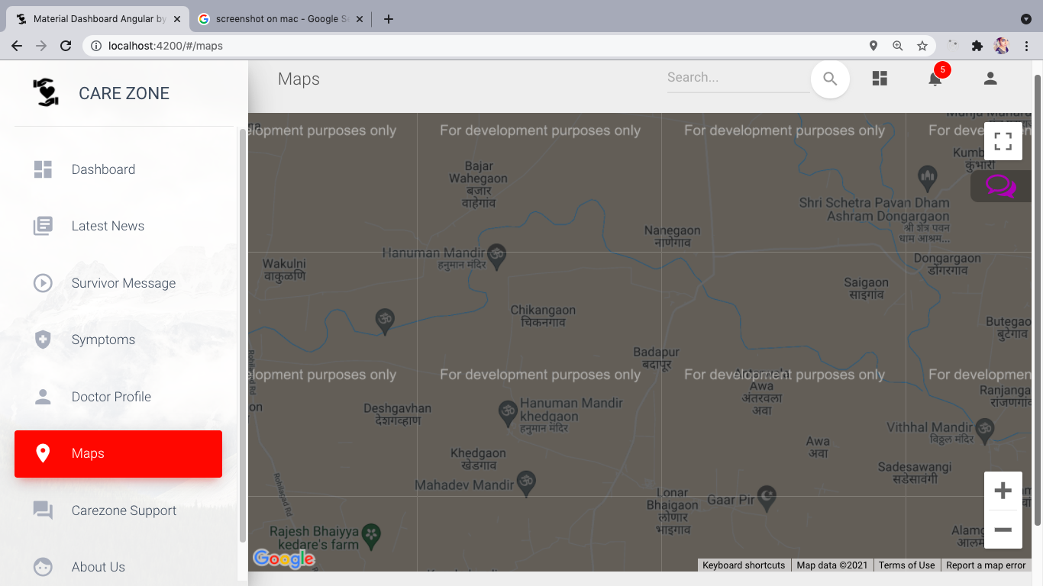

**DOCTOR’S PROFILE:**

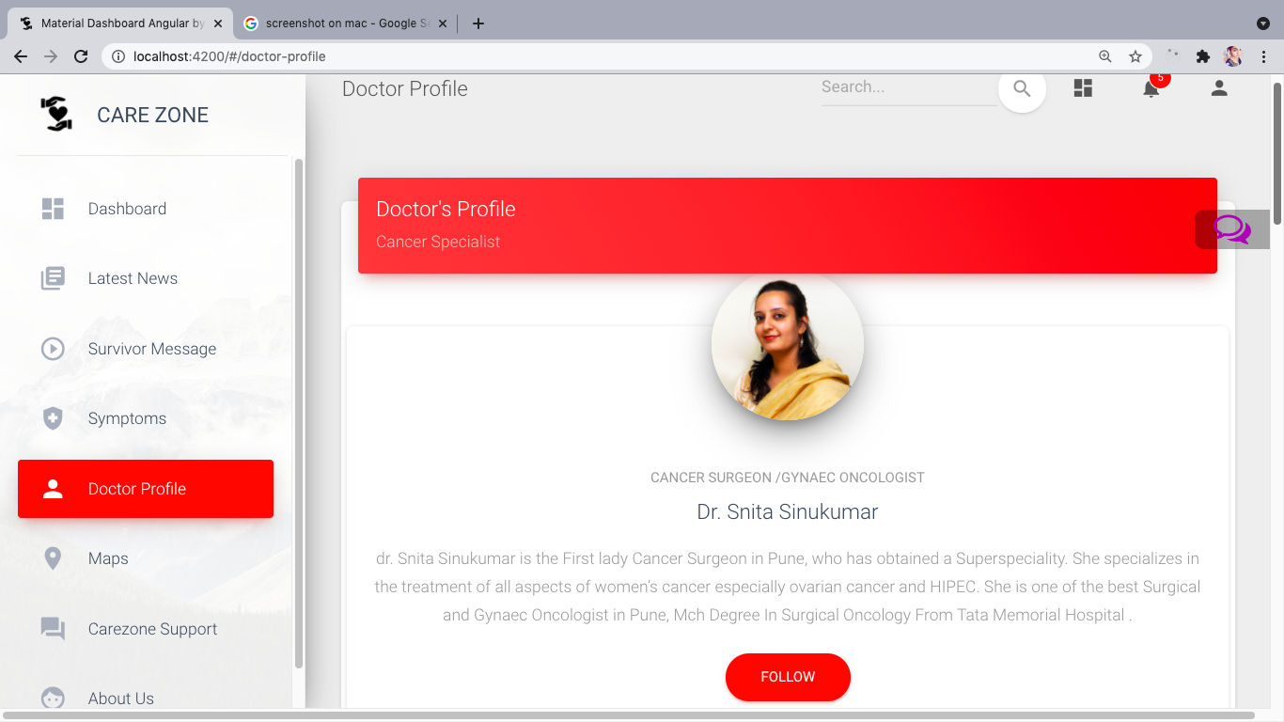

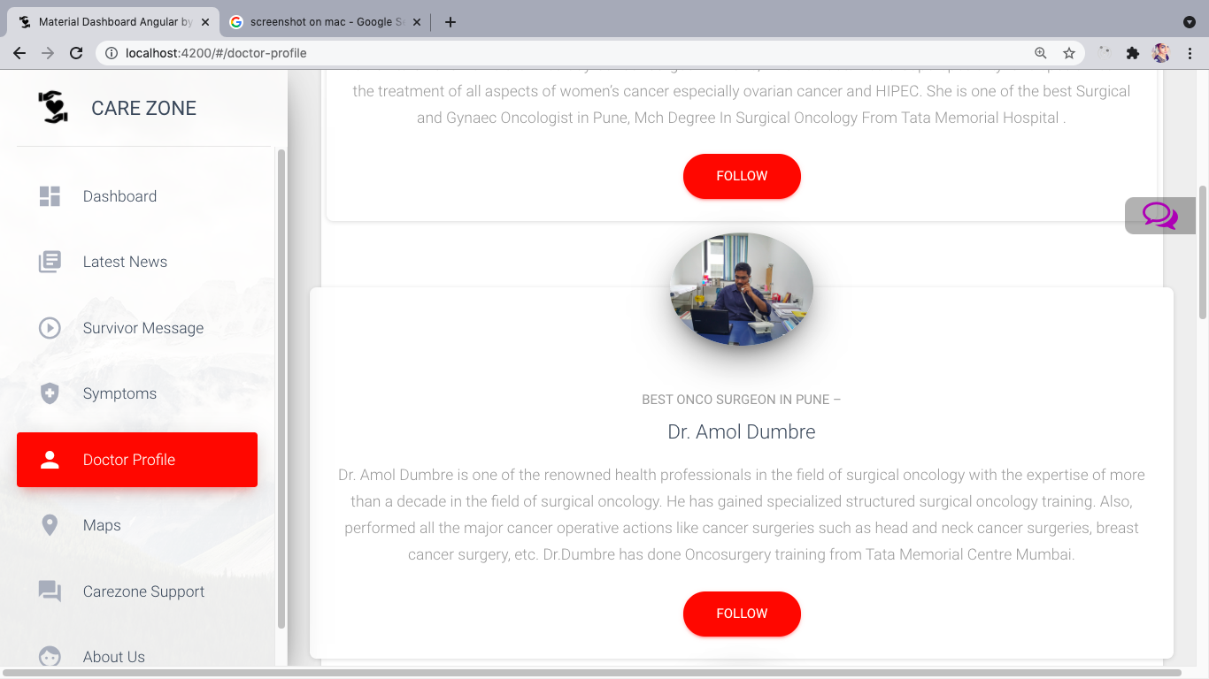

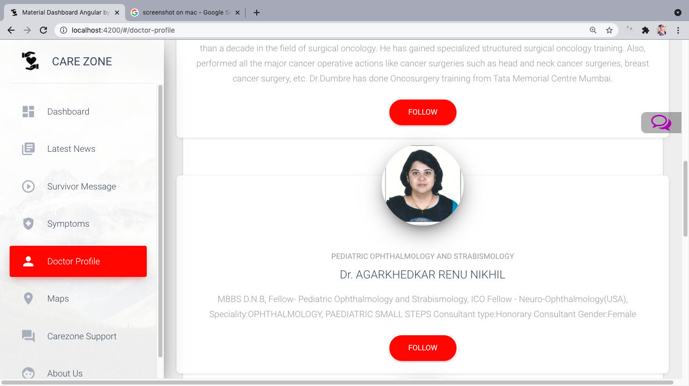

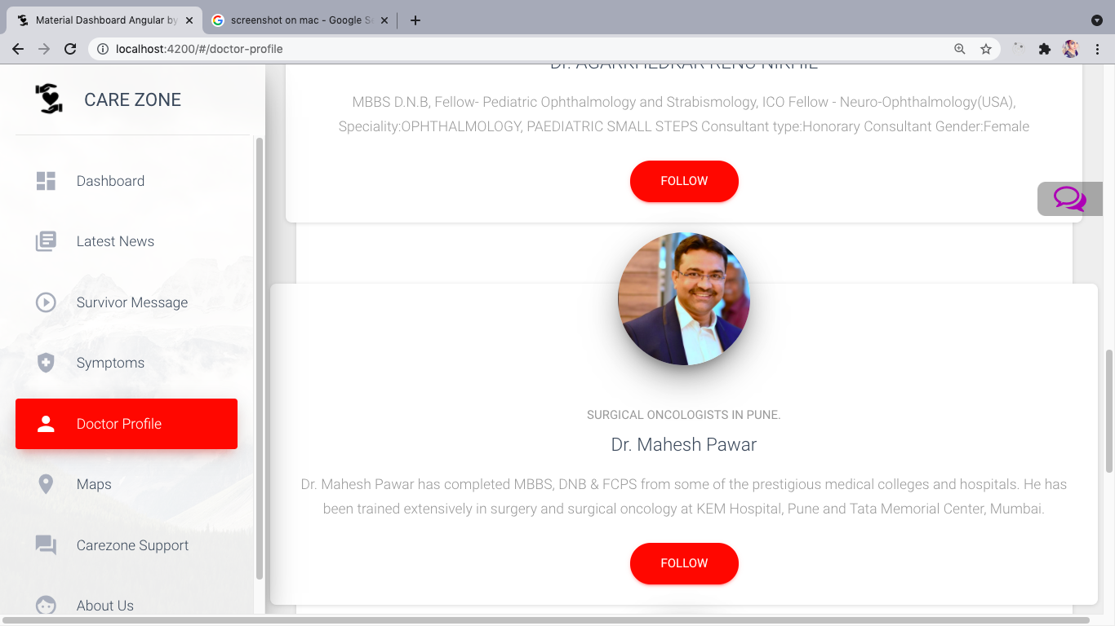

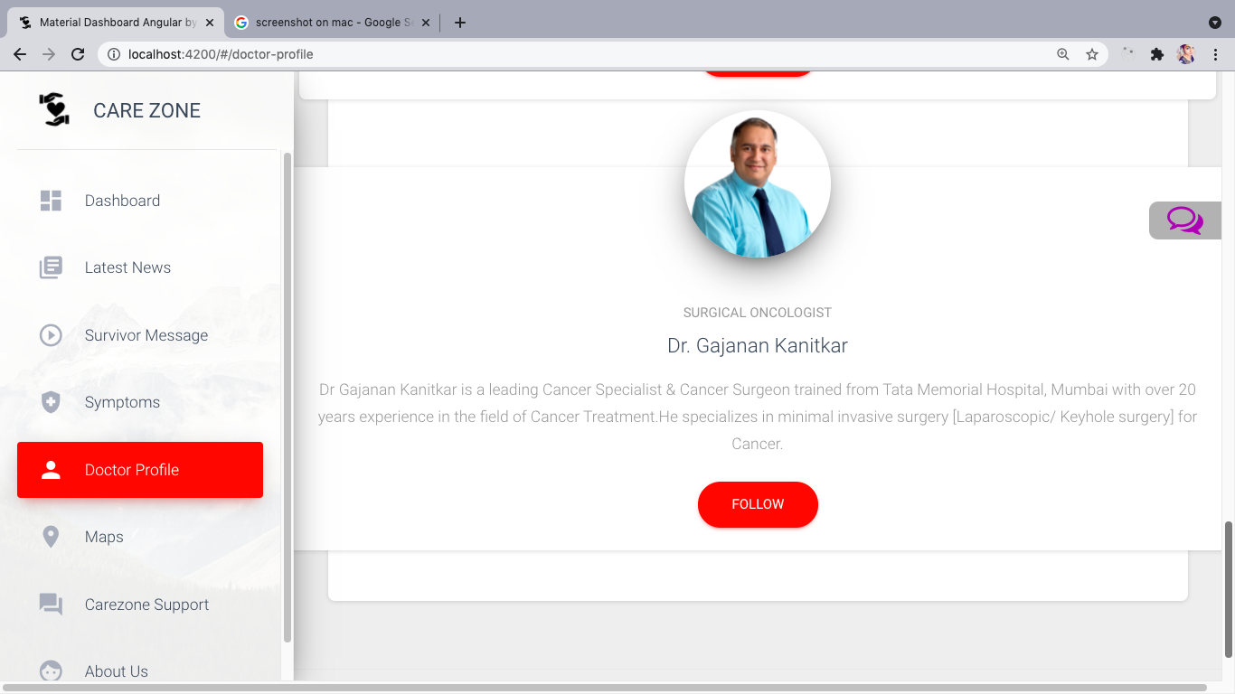

**CHATBOT:**

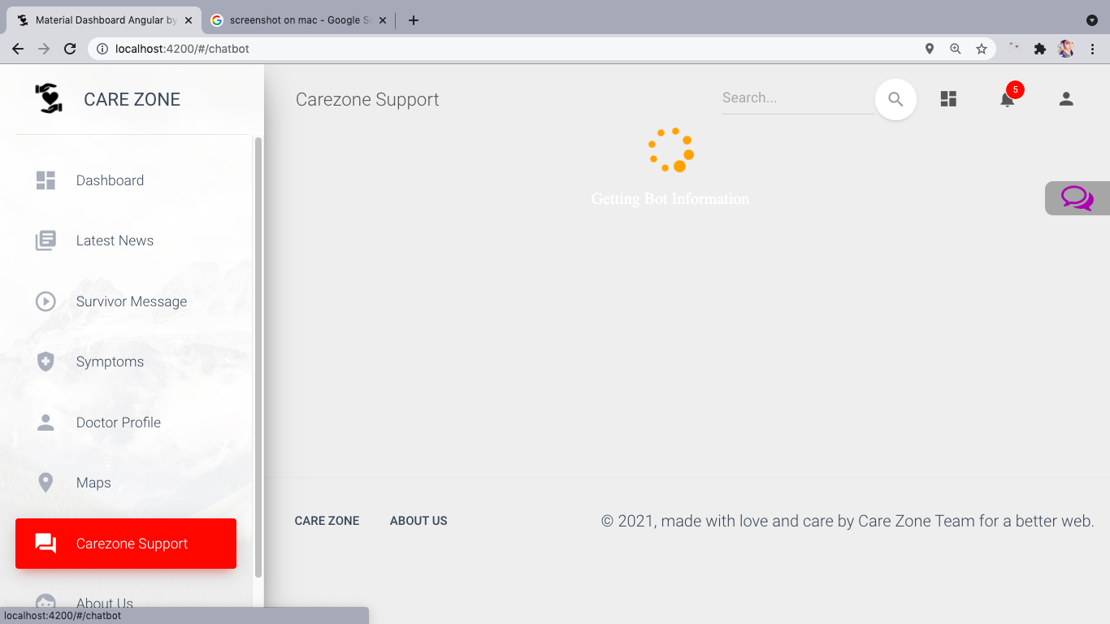

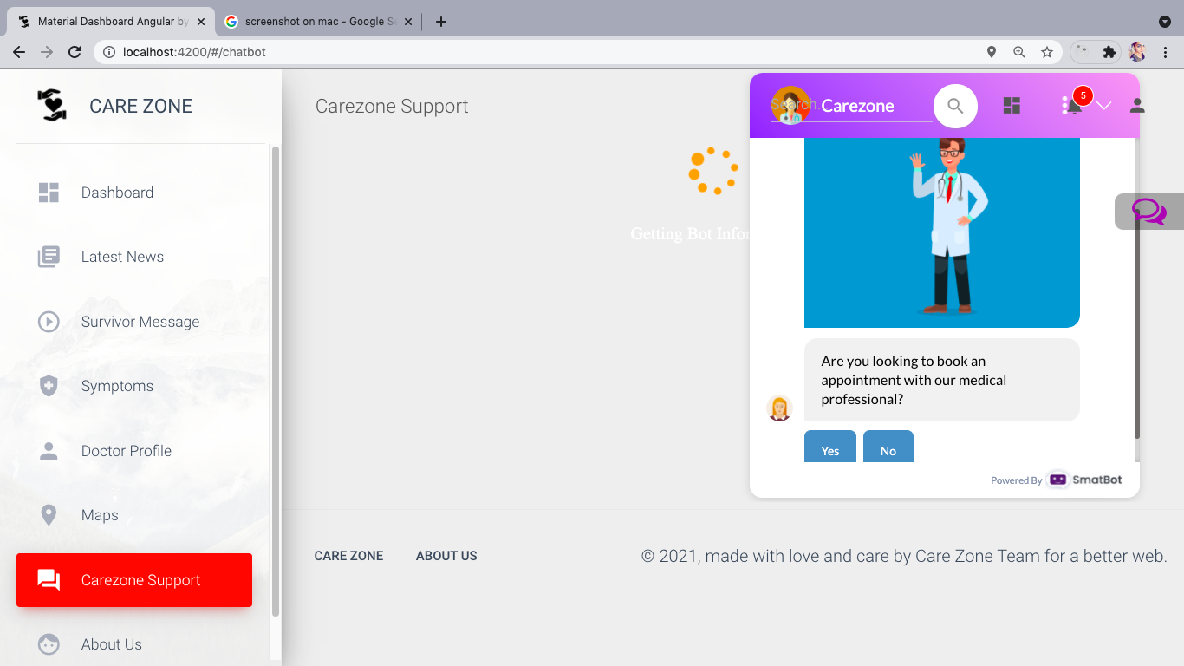

**ABOUT US:**

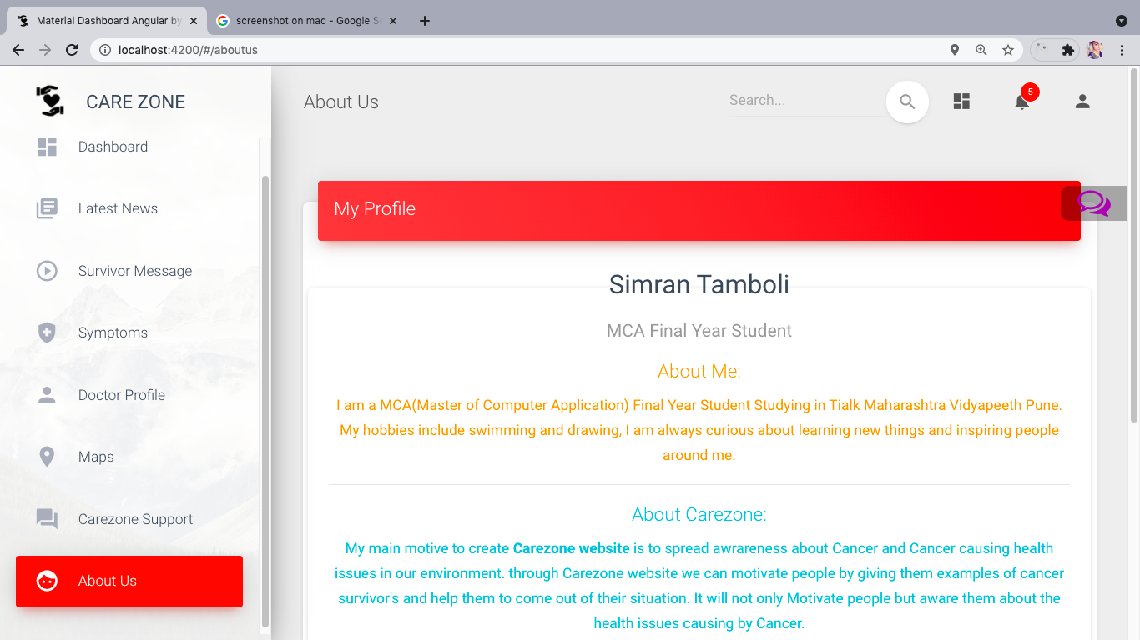

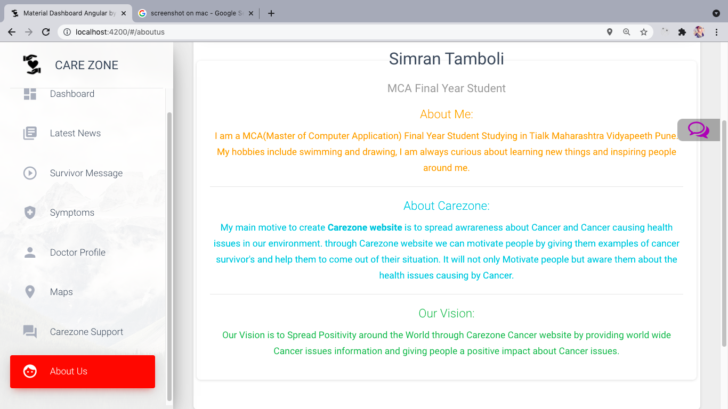

**FUTURE SCOPE**

* **User Management**
* **Patient Management**
* **Doctor Management**
* **Feedback System**
* **Notification System**
* **Audio/Video conferencing with Doctor/Patient**

**LIMITATION**

* **Limited access to data**
* **Time Constraints**
* **Issues with sample and selection.**
* **Insufficient sample size for statistical measurement.**
* **Lack of previous research studies on the topic.**

**CONCLUSION**

“Here, I have come to the end of the project on the topic CareZone. I tried my best to include all the necessary points that are required related to the given topic. Some of the information I wrote in the project were taken from the internet and I have also referred to some books. This project contains information of cancer and related issues, doctor information, hospital information etc. It was a wonderful and learning experience for me while working on this project. The joy of working and the thrill involved while tackling the various problems and challenges gave me a feel of the industry. I enjoyed each and every bit of work I had put into this project. I do hope that my project will be interesting and may be even knowledgeable.

**REFERENCES AND BIBILOGRAPHY**

**BOOK REFERED:**

* Angular Essentials Reference 3.8.
* Beginner Guide for Angular.
* Angular Material From Google.
* Firebase API.
* HTML CSS for Beginner.